**Styling React apps with modules.**

Setting dynamic styles.

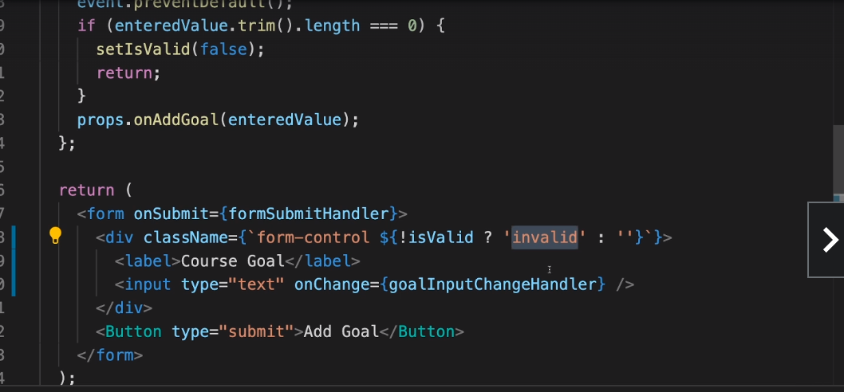

In the above example we are dynamically setting the css class name based on the class value.

Simply importing css file does not restrict the scope of css to that file. If more than one css file has a css class with the same name, then it would overwrite their respective css properties.

This is not however the expected behaviour everytime.Styles can spill over to other files.

There are two approaches to resolve this problem. First approach is the use of styles components and other is by the use of modules.

CSS modules are a better way because css files are kept different. Following are the steps to use css.

1. import styles from ‘./Button.module.css’
2. Change file name to Button.module.css.
3. Use the css in the following way <button type={props.type} className={styles.button}></button>

Dynamic styles with css modules.

